mTrip Product Requirements Document (PRD)

Merchant App - v 1.0

Author: Ms. May Shoon Lett Zaw
Team: Product Team

Product Manager | Mr. Aung Khant Kyaw
Engineering Lead/Team Lead | Mr. Li Sir
Designer | Mr. Chit Ko Ko
Approvers/Sign-Off

PM Sprint Planner: mTrip Sprint Plan
Status of PRD: In Progress

Table of Contents
Merchant App - v 1.0 1
Table of Contents 2
OverView 6
Problem 6
Objectives 7
Objective 1 7
Objective 2 7
Objective 3 7
Constraints 7
Constraint 1: MVP Scope and Timeline 7
Constraint 2: Limited Resources and Platform Readiness 8
Constraint 3: External System Dependencies 8
Persona 8
User Journey and Platform Workflow 9
Scenario 1- Hotel Merchant Registration & Verification 13
Objective 13
Workflow 13
Business Rules 13
Before Merchant Approval – Registration & Application Access 14
After Merchant Approval – Merchant Account Access 14
Returning Merchant Login – Mobile App 15
Returning Merchant Login – Web Portal 15
Authentication Business Rules 15
Scenario 2 - Hotel Configuration & Publication 16
Objective 16
Business Rules 17
Scenario 3 - Booking Management 18
Objective 18
Business Rules 18
Booking Payment Rules 19
End-to-End Platform Workflow 20
Functional Requirements 21
Portfolio & Business Domain Management 21
Functional Requirements 22
Merchant Dashboard 22
Functional Requirements 22
Property Selection 22
Operational Summary 22
Operational Alerts 23
Business Insights 23
Property Performance 23
Today's Operations 23
Module 1 – Registration, Verification & Admin Approval 24
Functional Requirements 24
1.1 Registration & Authentication 24
1.2 Merchant Profile 24
1.3 Merchant Verification (KYC) 24
1.4 Verification Workflow 25
1.5 Super Admin Approval 25
Module 2 – Hotel & Room Management 25
Functional Requirements 25
2.1 Room Type Management 26
Module 3 – Availability, Inventory & Pricing 27
Functional Requirements 27
3.1 Availability Management 27
3.2 Inventory Management 27
3.3 Pricing Management 28
3.4 Restrictions Management 28
3.5 Synchronization Management 28
3.6 Alerts & Notifications 28
3.7 Change History 29
Module 4 – Booking Management 29
Functional Requirements 29
4.1 Booking List Management 29
4.2 Booking Details 29
4.3 Booking Status Management 30
4.4 Guest Stay Management 30
4.5 Booking Actions 30
4.6 Notifications & Synchronization 31
4.7 Booking History & Timeline 31
4.8 Cancellation Management 31
Module 5 – Business Dashboard, Earnings & Settlement 34
Functional Requirements 34
5.1 Settlement Flow Overview 34
5.2 Commission 34
5.3 Refund Rules 35
Module 6 – Notifications & Settings 35
Functional Requirements 35
6.1 Notification Management 35
6.2 Notification Categories 35
6.3 Notification Content 36
6.4 Synchronization Alerts 36
6.5 Merchant Profile & Preferences 36
6.6 Security Settings 36
6.7 Localization 36
Module 7 – Role-Based Access Control (RBAC) & Staff Management 37
Functional Requirements 37
7.1 Staff Management 37
7.2 Role Management 37
7.3 Permission Management 37
7.4 Hotel Assignment 38
7.5 Invitation Management 38
7.6 Audit History 38
7.7 Staff Dashboard 38
Module 8 – Promotion & Campaign Management 39
Functional Requirements 39
Module 9 – Reviews & Ratings Management 39
Functional Requirements 39
Module 10 – Merchant Support & Help Center 40
Functional Requirements 40
10.1 Guest Messaging 40
10.2 Guest Conversations 40
10.3 Messaging 41
10.4 Booking Context 41
10.5 Notifications 41
10.6 Staff Assignment 41
Acceptance Criteria 42
1. Registration, Verification & Admin Approval 42
2. Hotel & Room Management 42
3. Availability, Inventory & Pricing 43
4. Booking Management 43
5. Business Dashboard, Earnings & Settlement 43
6. Notifications & Settings 43
7. RBAC & Staff Management 44
8. Promotion & Campaign Management 44
9. Reviews & Ratings Management 44
10. Merchant Support & Help Center 44
Design 45
Hotel Merchant App Information Architecture 45
Hotel Merchant App Role-Based Access Control (RBAC) 46
Design Link 47
Technical Considerations 47
PMS & Channel Manager Integration 48
Scenario 1 – Direct PMS Integration 48
PMS Integration 48
Channel Manager Integration 48
Business Rule 49
Additional Technical Considerations 49
Real-time Booking Notifications 49
Room Quota Synchronization 50
Scalability & Extensibility 50
Success Metrics 50
Open Issues 51
Q&A 51
Bookings made through the Customer App are synchronized to the Merchant App for management. 52
Feature Timeline and Phasing 52
Reference and Scope Note 53
PRD Checklist: 53

OverView
The mTrip Hotel Merchant App is a customized platform that allows hotel partners to effectively
manage their properties and everyday operations inside the mTrip ecosystem. The program, which is part of the Phase 1 MVP, gives hotel merchants the tools they need to manage room inventory, reservations, pricing, promotions, and company information from a single platform.

The program seeks to improve hotel operations by minimizing manual processes, increasing booking accuracy, and offering real-time visibility into reservation activities. Self-service management options enable hotel partners to easily respond to client bookings, adjust room availability, manage promotional campaigns, and track company performance.

The Hotel Merchant App is an important aspect of the mTrip ecosystem since it allows hotel partners to provide a seamless booking experience while also supporting the platform's goal of creating a trustworthy and scalable travel marketplace.
The platform will combine a daily operational workbench, controlled staff access, transparent settlement visibility, merchant marketing tools, and future affiliate ecosystem support. Ctrip EBK is used as an operational reference while mTrip-specific onboarding, two-factor authentication, and affiliate capabilities remain product differentiators.
Multi-Business Merchant Structure
The mTrip Merchant Platform supports a centralized portfolio structure that allows a merchant account to manage multiple properties and business types from a single account. The All Properties view serves as the portfolio-level entry point, where merchants can view and manage all registered businesses. Each property operates within its applicable business domain, such as Hotel or Restaurant, with domain-specific management modules and operational workflows. Shared merchant capabilities, including Dashboard & Earnings, Promotions, Reviews, Guest Messages, Staff Management, Support, and Settings, remain accessible across supported business domains.

Problem
Many hotels, particularly small and medium-sized ones, continue to manage reservations and room availability manually, using phone calls, messaging programs, spreadsheets, or various disconnected systems. These fragmented procedures increase operational workload, cause booking confirmation delays, and may result in overbooking, inaccurate room inventory, and inconsistent pricing.

As mTrip grows its hotel booking services, hotel partners want a centralized management platform that allows them to efficiently manage bookings, room availability, pricing, and promotional activities while providing customers with correct information in real time.

Without a specialized Hotel Merchant App, operational inefficiencies can have a severe impact on both hotel partners and customers, resulting in slower response times, lower booking accuracy, and decreased customer satisfaction.

Objectives

Objective 1
Provide hotel partners with a centralized platform to manage hotel operations, including property information, room inventory, pricing, bookings, promotions, staff access, customer reviews, and business performance.

Objective 2
Improve operational efficiency by reducing manual processes through real-time booking management, automated notifications, role-based access control, self-service administrative tools, and centralized merchant support.

Objective 3
Build a scalable merchant platform that enhances hotel partner satisfaction, improves the consumer booking experience, and supports the long-term growth of the mTrip travel ecosystem.

Constraints

Constraint 1: MVP Scope and Timeline
The Hotel Merchant App will be developed as part of the Phase 1 MVP within the project timeline. To ensure timely delivery, the initial release will focus on core hotel management capabilities, including merchant onboarding, hotel and room management, availability and pricing, booking management, dashboard and earnings, staff management, promotions, reviews, notifications, and merchant support. Advanced capabilities and third-party integrations will be delivered in future phases.

Constraint 2: Limited Resources and Platform Readiness
As a new platform, the Hotel Merchant App will be developed alongside other core mTrip services, including the Consumer App, Super Admin Portal, payment services, and supporting platform infrastructure. Development priorities, technical dependencies, and available engineering resources may influence the implementation sequence of individual features.

Constraint 3: External System Dependencies
Several core capabilities depend on third-party services and external integrations, including KYC verification, payment gateways, SMS/OTP services, push notifications, settlement processing, PMS integrations, Channel Manager integrations, and mapping services. The availability, performance, and reliability of these external systems may affect feature delivery and user experience.

Persona

Persona | Description
Key Persona- Hotel Manager/Admin | Responsible for directing daily hotel operations, managing reservations, checking room availability, adjusting price, generating promotions, and assessing company performance. The Hotel Merchant App's principal user and decision-maker is the hotel manager.
Persona 2 – Reservation Officer/Editor | Responsible for receiving incoming reservations, confirming or amending bookings, updating room availability, managing guest information, and responding to client requests. The daily booking processes are the main emphasis of this user.
Persona 3 - Hotel Owner / Business Owner | Responsible for evaluating overall hotel performance, examining revenue and occupancy records, managing promotional programs, and making business choices based on operational information. This user may utilize the application less frequently but relies on business statistics and reporting.

User Journey and Platform Workflow
The following user journeys describe how hotel merchants interact with the mTrip Hotel Merchant App throughout the merchant lifecycle. These workflows illustrate the key operational processes, from merchant registration and Merchant Operations review to business verification (KYC), hotel configuration, booking management, and business monitoring. The Hotel Merchant App works closely with the Merchant Operations Team, Super Admin Portal, and Customer App to facilitate merchant onboarding, business verification, hotel publication, customer bookings, and real-time synchronization across the mTrip ecosystem.

Figure: End-to-End Merchant Registration, Approval and Authentication Flow — Mobile App and Web Portal

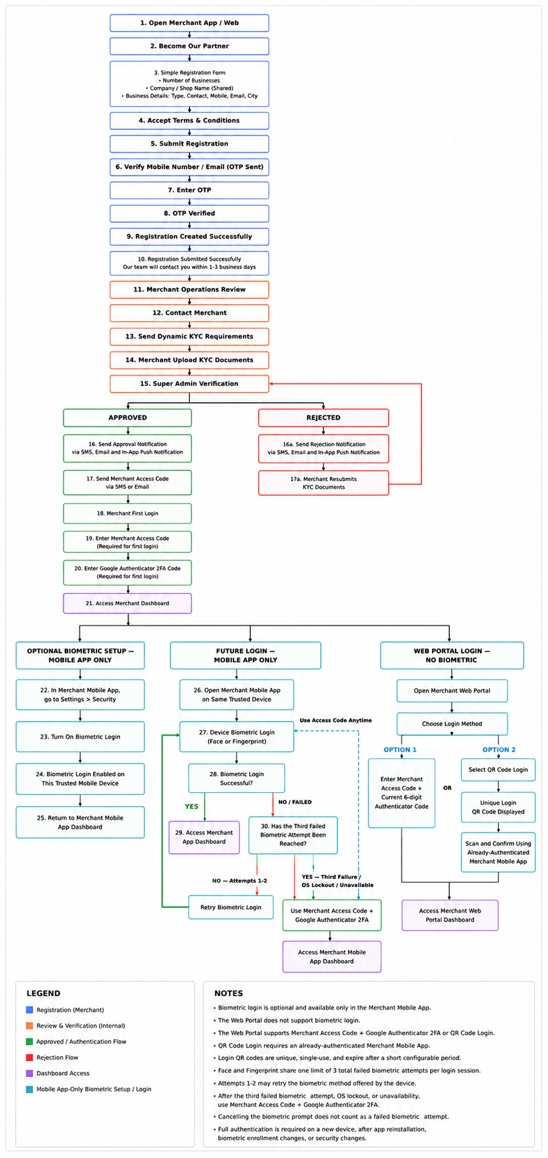

Diagram 1 - High-Level Merchant App Workflow for 2FA
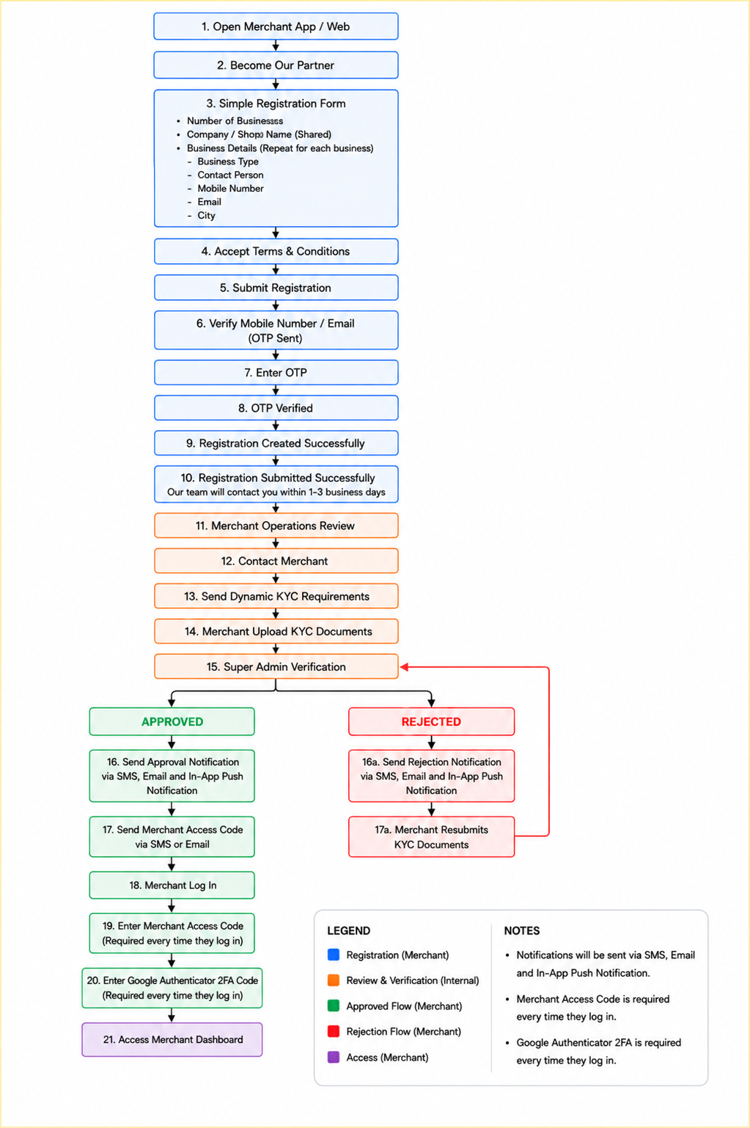

Diagram 2 - Merchant Basic Registration Form Flow

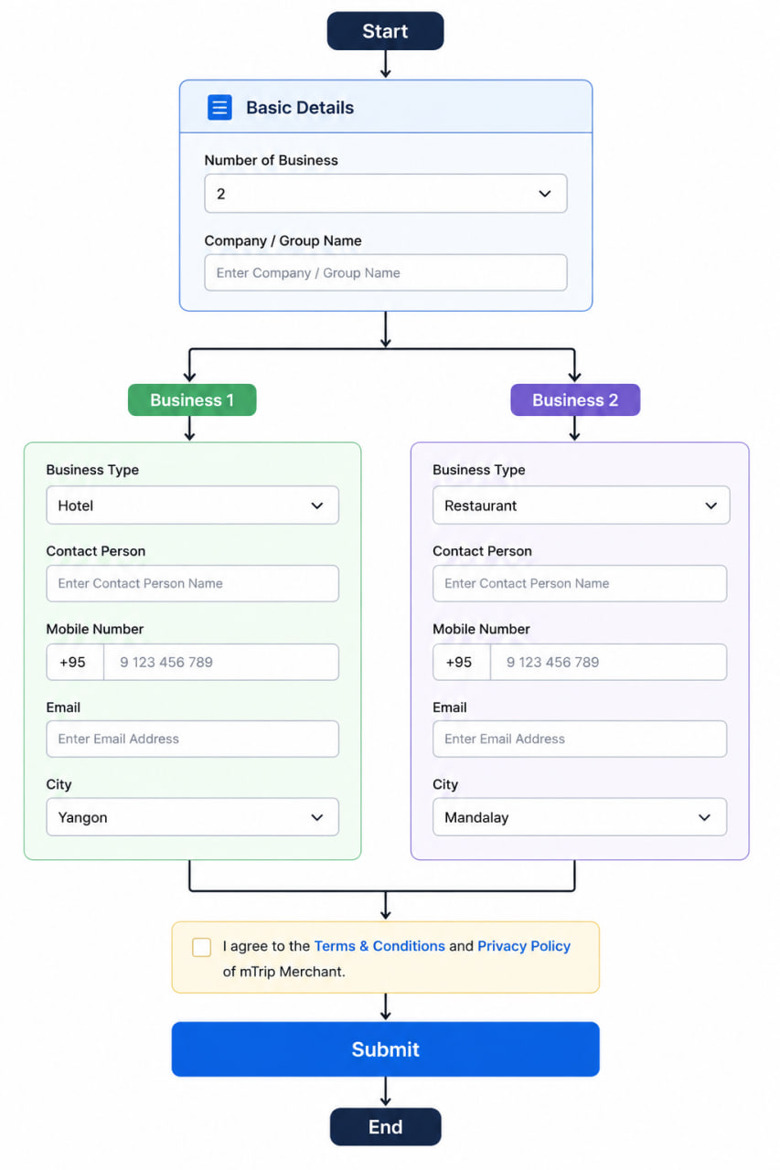

Diagram 3 - Merchant 2 FA setup & Login Flow

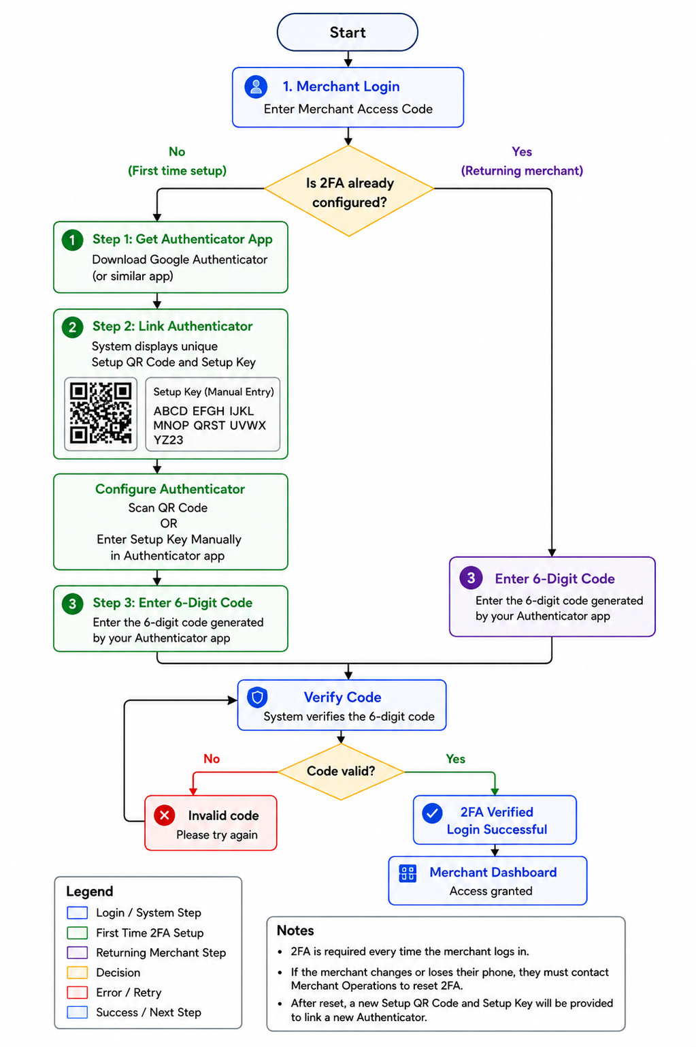

Scenario 1- Hotel Merchant Registration & Verification

Objective
Allow a new hotel merchant to register interest in joining the mTrip platform, complete business verification (KYC), receive approval from the Super Admin, and securely access the Merchant Dashboard. The onboarding process includes merchant registration, Merchant Operations review, business verification, approval, and secure account access.

Workflow
The merchant onboarding process begins when a prospective merchant registers through the Merchant App or Web Portal. The merchant verifies their mobile number or email using OTP and submits the registration form after accepting the Terms & Conditions.
The Merchant Operations Team reviews the registration, contacts the merchant, and assigns the required KYC documents based on the merchant's business type. The merchant uploads the requested documents, which are reviewed by the Super Admin.
Once approved, the merchant receives an approval notification and a unique Merchant Access Code via SMS and/or email. The merchant then completes mandatory two-factor authentication using an Authenticator app before accessing the Merchant Dashboard.

Business Rules
- Merchant selects Become Our Partner.
- Merchant completes and submits the registration form.
- Merchant must accept the Terms & Conditions and Privacy Policy.
- Mobile number or email must be verified using OTP.
- Merchant Operations (mTrip) reviews the registration.
- Merchant Operations (mTrip) contacts the merchant.
- Dynamic KYC requirements are assigned based on the merchant's business type.
- Merchant uploads the required KYC documents.
- Super Admin approves or rejects the application.
- Rejected merchants may correct and resubmit their KYC documents.
- Approved merchants receive an approval notification and Merchant Access Code via SMS and/or email and in-app push notification.
- Approved merchants must complete mandatory 2FA before accessing the Merchant Dashboard.
- Approved merchants may manage one or more properties under the same merchant account.
- Existing verified merchants adding additional properties do not repeat merchant-level KYC. Only applicable property-specific verification documents are required.

Before Merchant Approval – Registration & Application Access
Prospective merchants can access registration and KYC-related functions through the Merchant Mobile App or Merchant Web Portal.
Registration Authentication
- Enter mobile number or email address.
- Receive OTP.
- Verify OTP.
- Complete registration and accept Terms & Conditions.
- Submit registration.
- Merchant may subsequently access their application using the verified contact method to:
  - View application status.
  - View assigned KYC requirements.
  - Upload KYC documents.
  - Correct and resubmit requested documents.
Applicants cannot access the Merchant Dashboard before approval.
Application Status
Registration Submitted → Under Review → KYC Required → KYC Submitted → Under Verification → Approved / Rejected / Resubmission Required

After Merchant Approval – Merchant Account Access
Once Super Admin approves the merchant:
- The merchant receives an approval notification via SMS and/or email with , as well as an in-app push notification.
- Merchant receives a unique Merchant Access Code via SMS and/or email.
- Mandatory 2FA must be configured before Merchant Dashboard access is granted.
First-Time 2FA Setup
- Enter Merchant Access Code.
- If an Authenticator app is not installed, the merchant is prompted to install Google Authenticator depend on IOS or Android
- The system displays a unique Setup QR Code and Setup Key. QR Code and Key code should not be expired.
- Merchant links the Authenticator by either:
  - Scanning the Setup QR Code, or
  - Entering the Setup Key manually.
- Authenticator app generates a 6-digit verification code.
- The merchant enters the 6-digit code.
- The system verifies the code.
- Merchant accesses the Merchant Dashboard.

Returning Merchant Login – Mobile App
- Enter Merchant Access Code.
- Enter the current 6-digit code generated by the linked Authenticator app.
- After successful verification, access the Merchant Dashboard.

Optional Biometric Login - Mobile App Only

Scope clarification: Biometric login applies only to the mTrip Merchant Mobile App. It is not available on the Merchant Web Portal/Dashboard.

Enablement:
The merchant must complete the first login using the Merchant Access Code and the current 6-digit Google Authenticator code. After accessing the Merchant Mobile App Dashboard, the merchant may manually enable biometric login by navigating to:
Merchant Mobile App Dashboard > Settings > Security > Biometric Login
When the merchant turns on Biometric Login from Merchant Mobile App Settings > Security, biometric login shall be enabled for future logins on the same trusted mobile device.
For subsequent logins, the merchant may use a biometric method already registered on the mobile device, such as Face Scan, or Fingerprint, instead of entering the Merchant Access Code and Google Authenticator code.
This biometric login process is only for accessing the Merchant Mobile App. It shall not require the merchant to complete KYC again or perform liveness detection, facial identity verification, document verification, or a new face-registration process.
The Merchant Mobile App shall not capture, store, or compare the merchant’s facial image or fingerprint information. Biometric authentication shall be handled by the mobile device.
The biometric login screen, instructions, retry messages, error states, and Use Merchant Access Code option shall follow the approved mTrip UI/UX design.
The device’s biometric confirmation window may follow the mobile operating system’s standard appearance. All screens and messages displayed by the mTrip Merchant Mobile App before and after that window shall align with the approved mTrip design.
After successful biometric authentication, the merchant shall be granted access to the Merchant Mobile App Dashboard.
Eligibility:
The merchant is eligible to use biometric login when all the following conditions are met:
- The merchant has completed the first login using the Merchant Access Code and Google Authenticator 2FA.
- The merchant has manually enabled biometric login from Merchant Mobile App Settings > Security.
- The mobile device supports at least one biometric authentication method.
- At least one supported biometric method is enrolled on the mobile device.
- The merchant is attempting a subsequent login on the same trusted mobile device.
- The trusted-device authentication credential remains valid.
Biometric Login Business Rules:
- The app shall invoke the device operating system’s native biometric prompt and accept any supported and enrolled biometric method, such as Face Scan or Fingerprint.
- If both Face and Fingerprint authentication are available, the device operating system shall manage the available biometric method.
- Switching between supported biometric methods during the same login session shall not reset the failed-attempt count.
- The merchant may make up to three total failed biometric matching attempts per login session across all supported biometric methods, subject to any stricter device or operating-system limit. For example, two failed Face authentication attempts followed by one failed Fingerprint attempt shall equal three total failed biometric attempts.
- After the third total failed biometric attempt, or when the operating system reports biometric lockout or unavailability, biometric login shall stop. The merchant must then authenticate using the Merchant Access Code and the current 6-digit Google Authenticator code.
- The merchant may select Use Merchant Access Code at any time without waiting for three failed biometric attempts.
- Cancelling or closing the biometric prompt shall not be counted as a failed biometric match.
- Successful biometric verification shall grant access to the Merchant Mobile App Dashboard.
- A new mobile device, app reinstallation, biometric enrollment change, removal of enrolled biometrics, or relevant device security change shall invalidate biometric login for that device.
- Following such a change, the merchant must complete full authentication using the Merchant Access Code and Google Authenticator 2FA. The merchant must then manually enable biometric login again from Merchant Mobile App Settings > Security on the trusted mobile device.

Returning Merchant Login – Web Portal ( No Biometric Login)
Two authentication methods are supported.
Option 1 – Merchant Access Code + Authenticator
- Enter Merchant Access Code.
- Enter the current 6-digit Authenticator code.
- Access MerchantWeb Portal Dashboard.
Option 2 – QR Code Login
- Open the Merchant Web Portal.
- Select QR Code Login.
- A unique login QR code is displayed.
- Open the already-authenticated mTrip Merchant Mobile App.
- Scan the login QR code.
- Confirm the login request on the mobile device.
- Web Portal automatically authenticates the merchant.

Authentication Business Rules
- Applicants can access only registration, KYC submission, resubmission, and application-status functions before approval.
- Merchant Dashboard access is available only to approved merchants.
- Registration OTP is used for verifying the merchant's mobile number/email during the pre-approval process.
- Merchant Access Code + Authenticator verification are used for approved merchant account access.
- Approval notification and Merchant Access Code are sent via SMS and/or email and in-app push notification.
- 2FA setup QR codes and setup keys are unique to the applicable merchant/user account.
- Returning merchants who have already configured 2FA do not repeat the Authenticator setup process.
- QR Login is available only for the Web Portal and requires an already-authenticated Merchant Mobile App.
- Login QR codes must be unique, single-use, and expire after a short configurable period.
- If a merchant loses the device linked to the Authenticator, 2FA must be reset according to the approved account-recovery process before a new Setup QR Code and Setup Key are issued.
- Biometric login is an optional Merchant Mobile App feature only and shall not be displayed or offered on the Merchant Web Portal/Dashboard.
- The Merchant Web Portal shall require the Merchant Access Code and the current 6-digit Google Authenticator code for login. Biometric login shall not be available on the Merchant Web Portal.
- The maximum of three failed biometric attempts is counted across all available biometric methods within the same login session, not separately for Face and Fingerprint.
- Device and operating-system biometric lockout rules take precedence. If the device blocks biometric authentication before the mTrip limit is reached, the app shall immediately require Merchant Access Code + Google Authenticator 2FA.

Customer Support During Registration:
- Users can access Customer Support during the registration process before merchant approval.
- The Customer Support modal displays the support email address and phone number.
- Users can copy the support email address using the Copy icon or click the email address to open their default email application via a mailto hyperlink.
- Users can directly initiate a phone call using the Call button.
- Support operating hours are displayed in the modal, if applicable.

Scenario 2 - Hotel Configuration & Publication

Objective
Allow approved merchants to configure hotel properties and publish them to the mTrip Consumer App after completing the required operational setup.

Workflow
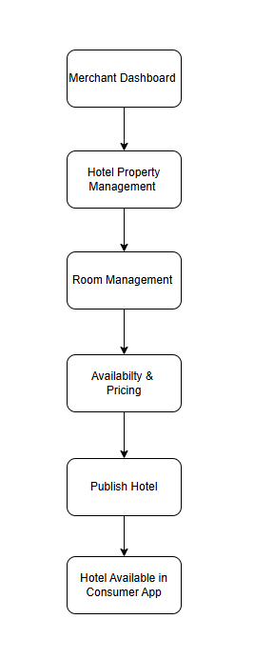

Business Rules
- Only approved merchants can create hotel properties.
- A merchant account may manage multiple hotel properties.
- Hotel information can be saved as Draft.
- Required information must be completed before submission.
- PMS and Channel Manager synchronization are supported where applicable.
- Hotels without integration manage operations directly in the Merchant Portal.
- Only Published hotels appear in the Customer App.

Expected Outcome
The hotel becomes available for customer search and booking.

Scenario 3 - Booking Management

Objective
Allow merchants to receive, manage, and fulfill hotel bookings made through the mTrip Consumer App while maintaining synchronized booking information across the Merchant App, Consumer App, Admin Portal, and supported integrated systems.
Workflow
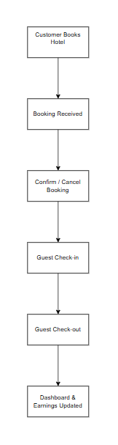

Business Rules
- Booking requests submitted through the Customer App are synchronized to the Merchant App in real time.
- Merchants receive notifications for new bookings, booking updates, cancellations, and operational events.
- Booking status is synchronized with connected PMS or Channel Manager integrations where supported.
- Hotels without PMS or Channel Manager integration manage booking operations directly through the Merchant Portal.
- Merchants can review booking details, guest information, payment status, and booking history.
- Merchants can confirm, modify, or cancel bookings according to platform policies and business rules.
- Check-in and Check-out can only be performed for confirmed bookings.
- Merchants can mark eligible guests as No Show according to the configured business rules.
- Booking completion automatically updates room availability, occupancy, revenue, settlement information, and business performance metrics.
- All booking activities are recorded for operational history, reporting, and audit purposes.
- Merchants can mark eligible guests as No Show according to the configured business rules.

Booking Payment Rules
- When a customer selects a room and proceeds to payment, the booking is created with a Pending Payment status.
- The selected room inventory is temporarily reserved for 10 minutes while the customer completes payment.
- During the reservation period, the room cannot be booked by another customer.
- If payment is successfully completed within 10 minutes, the booking status changes to Confirmed, and the reservation becomes a valid booking.
- If payment is not completed within 10 minutes, the pending booking automatically expires, the room inventory is released back to available stock, and the customer must create a new booking to reserve the room again.
- Expired pending bookings are retained in the system for audit and reporting purposes but are not treated as confirmed bookings or included in merchant settlement calculations.

Booking Status Flow
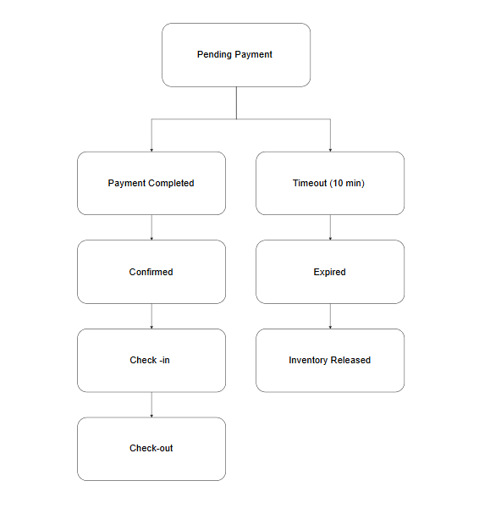

Expected Outcome
Booking information remains synchronized across the Merchant App, Customer App, and Admin Portal, enabling merchants to efficiently manage reservations while maintaining accurate operational and financial data.

End-to-End Platform Workflow
Description
The following workflow illustrates the complete interaction between the Merchant App, Admin Portal, and Customer App throughout the hotel merchant lifecycle. It demonstrates how merchant onboarding, hotel publication, customer bookings, and booking management are synchronized across the mTrip ecosystem.
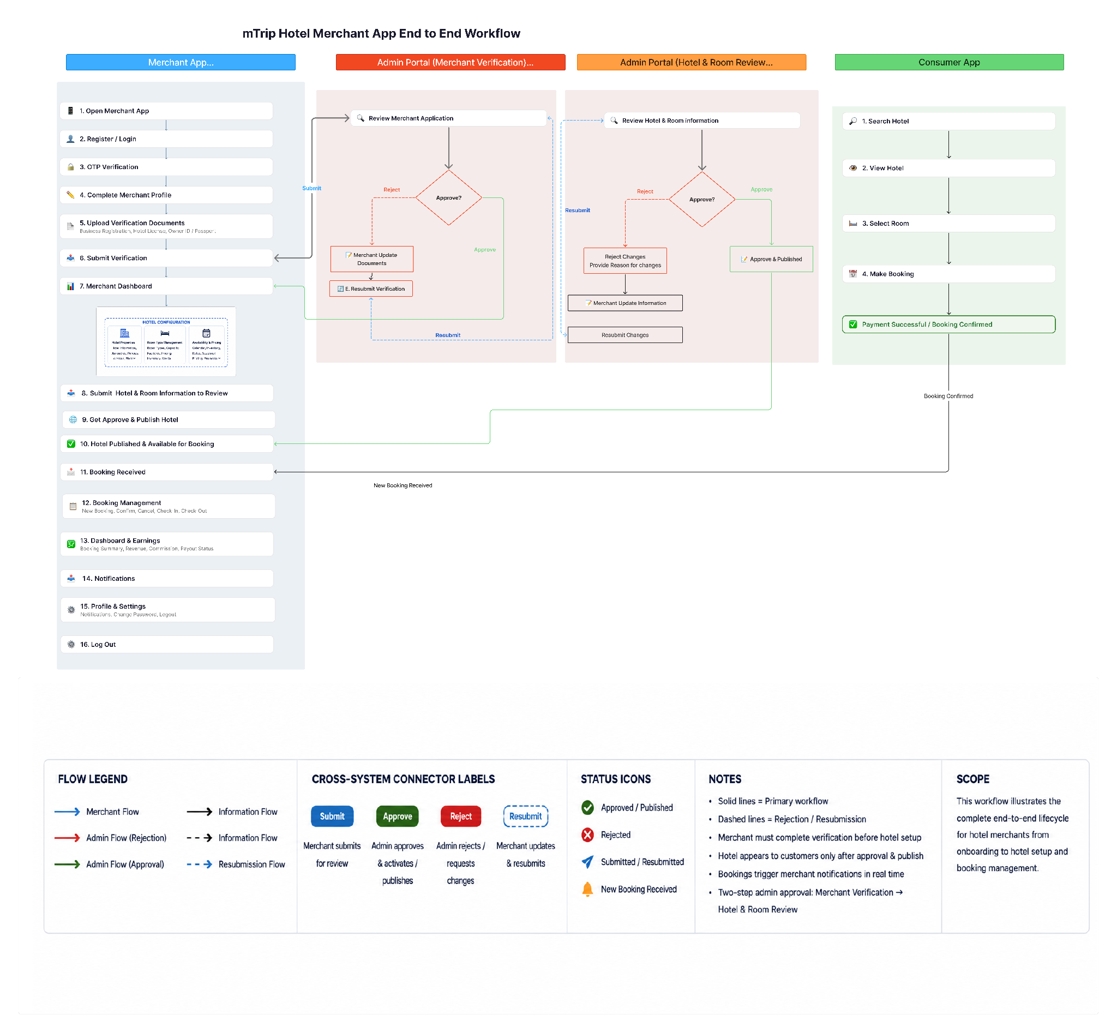

Functional Requirements
The functional scope is organized using the same module names as the Sprint Planning Sheet. Ctrip EBK is used as a reference for mature hotel operations; final mTrip implementation remains subject to business, design, and technical validation.

Portfolio & Business Domain Management
Goal
Enable merchants to manage multiple properties and business domains from a single merchant account.

Functional Requirements
- Merchants can view all properties associated with their account from a centralized All Properties view.
- The portfolio may contain properties from different supported business domains, such as Hotels and Restaurants.
- Properties are grouped or identified by business domain.
- Merchants can select a property to access its corresponding management functions.
- Hotel properties provide access to hotel-specific functions such as Hotel Properties, Room Types, Availability & Pricing, and Booking Management.
- Restaurant properties provide access to restaurant-specific functions such as Restaurant Profile, Menu Management, Table Reservations, and Operating Hours.
- Shared merchant functions such as Dashboard & Earnings, Promotions, Reviews, Guest Messages, Staff Management, Support, and Settings remain available across supported business domains.
- Merchants can add additional properties subject to the applicable registration, verification, and approval requirements.

Merchant Dashboard
Goal: Provide merchants with a centralized operational overview across all managed hotel properties, enabling them to monitor business performance, booking activities, occupancy, revenue, and operational alerts from a single dashboard.

Functional Requirements

Property Selection
- Support All Properties and individual property selection.
- Dashboard metrics, charts, and tables shall refresh based on the selected property.

Operational Summary
Display key operational KPIs:
- Total Hotels
- Today's Bookings
- Today's Check-ins
- Today's Check-outs
- Current Guests
- Occupancy Rate
- Revenue Today
- Pending Confirmations
- Pending Settlement
- Active Promotions

Operational Alerts
Display important operational notifications, including:
- PMS synchronization failures
- Connection timeout
- System notifications
- Property-related operational alerts
Merchants shall be able to view detailed logs when applicable.

Business Insights
Display business performance charts:
- Revenue Trend
- Occupancy Trend
- Booking Trend

Property Performance
Display a summary table showing:
- Hotel Name
- Today's Bookings
- Occupancy
- Revenue Today
- Property Status

Today's Operations
Display bookings requiring merchant attention, including:
- Hotel
- Booking ID
- Guest
- Room
- Check-in Date
- Check-out Date
- Booking Status
Navigation : Merchants shall be able to navigate directly to the relevant management modules, including Hotel Properties and Booking Management from the dashboard.

Module 1 – Registration, Verification & Admin Approval
Goal: Enable hotel merchants to register securely, verify their identity and business, submit required documents, track verification status, and access the platform after Super Admin approval.

Functional Requirements

1.1 Registration & Authentication
- Register using a mobile number with OTP verification.
- Authenticate merchants using the approved authentication method with mandatory two-factor authentication (2FA).
- Allow approved merchants to securely log in to the Merchant Portal.
- Support QR Code Login as an enhancement.
- Support optional biometric login for returning merchants only in the mTrip Merchant Mobile App after successful full authentication and trusted-device registration.
- Do not provide Face Scan, or Fingerprint login on the Merchant Web Portal/Dashboard.
- Enforce a maximum of three total failed biometric attempts per login session across all supported biometric methods before requiring Merchant Access Code + Google Authenticator 2FA, subject to stricter device or operating-system lockout rules.

1.2 Merchant Profile
- Create and manage merchant business profiles.
- Capture required business and contact information.
- Allow merchants to save registration progress as a draft before submission.

1.3 Merchant Verification (KYC)
- Upload and submit required business verification documents.
- Support required documents, including:
  - Business Registration Certificate
  - Hotel Operating License
  - Owner / Authorized Representative NRC or Passport
  - Bank Account Information
  - Bank Passbook / Bank Certificate
  - Tax Registration Certificate
  - Premises Ownership / Lease Agreement
  - Organogram / Structure Chart (For merchant with multiple properties)

1.4 Verification Workflow
- Manage the merchant application lifecycle:
- Draft
- Submitted
- Under Review
- Approved
- Rejected
- Display verification status throughout the review process.
- Display rejection reasons and allow merchants to correct information and resubmit applications.
- Support property-specific verification for merchants who have already completed merchant verification (KYC).
- When an approved merchant adds a new property, only the required property-specific verification documents shall be requested. Previously approved merchant KYC information shall remain valid unless re-verification is required due to changes in business information or regulatory requirements.

1.5 Super Admin Approval
- Allow Super Admin to review merchant applications and supporting documents.
- Approve or reject merchant applications based on verification results.
- Generate a Merchant Access Code upon successful approval.
- Grant access to the Merchant Dashboard after successful approval and authentication.

Module 2 – Hotel & Room Management
Goal: Enable approved merchants to create, manage, and maintain hotel and room information displayed to customers while ensuring all published content complies with platform quality standards before being published.

Functional Requirements
- A single merchant account shall be able to create and manage multiple hotel properties under the same account, subject to assigned user permissions.
- Merchants shall be able to view, search, filter, and manage hotel properties by hotel name, property status, and location.
- Merchants shall be able to create, edit, view, and maintain hotel information, including hotel name, property type, description, star rating, address, location, contact information, website, and Google Map location.
- Merchants shall be able to configure hotel amenities, including hotel facilities, guest amenities, and standard property services displayed to customers.
- Merchants shall be able to configure hotel policies, including check-in/check-out time, children policy, smoking policy, pet policy, extra bed policy, breakfast policy, cancellation policy, and house rules.
- Merchants shall be able to create, edit, duplicate, delete, and manage room types for each hotel property, including room name, room description, room size, bed type, occupancy, room facilities, room images, room lifecycle status, and room availability configuration.
- Merchants shall be able to upload, edit, reorder, categorize, preview, and manage hotel and room media, including hotel photos, room images, cover photo selection, image quality validation, approved photo limits, and one optional promotional hotel video (maximum 7 seconds).
- Merchants shall be able to configure optional value-added services, including breakfast packages, spa & wellness, laundry service, room service, extra bed, and late check-out. (Airport Transfer = Future Phase.)
- Merchants shall be able to save hotel and room information as a draft, preview changes, submit updates for review, monitor review status, view rejection reasons, review approval history, and resubmit rejected information. Previously approved information shall remain visible to customers until the latest submitted changes are approved.
- Hotels with existing Property Management Systems (PMS) shall be able to integrate through supported APIs to synchronize hotel information, room types, inventory, pricing, and booking status.
- Hotels without an existing PMS shall be able to use the mTrip Merchant Portal as their primary Property Management System (PMS) to manage hotel information, room types, inventory, pricing, and bookings.
- Channel Manager integration shall synchronize room availability, inventory, room quota allocation, booking status, and pricing across supported Online Travel Agencies (OTAs).

2.1 Room Type Management
Functional Requirements
- Merchants shall be able to create, edit, duplicate, delete, and manage room types for each hotel property.
- Merchants shall be able to configure room information, including room type name, room code, room description, bed type, number of beds, room size, floor, room view, smoking preference, maximum adult capacity, maximum child capacity, and maximum guest capacity.
- Merchants shall be able to configure room facilities and amenities available for each room type.
- Merchants shall be able to upload, edit, preview, replace, and delete room images, with support for cover photo selection, image quality validation, approved photo limits, and one optional room video.
- Merchants shall be able to configure room pricing, including base price, weekend price, currency, and extra bed pricing.
- Merchants shall be able to configure room inventory, including total physical rooms and initial available rooms at launch.
- Merchants shall be able to configure room-specific policies, including cancellation policy, meal plan, and check-in notes.
- Merchants shall be able to save room information as a draft, submit room types for review, monitor approval status, view rejection reasons, and resubmit rejected room information. Previously approved room information shall remain visible to customers until the latest submitted changes are approved.
- Room types shall be associated with a specific hotel property and used for inventory management, availability, pricing, booking management, and customer-facing hotel listings.

Module 3 – Availability, Inventory & Pricing
Goal: Enable merchants to manage room availability, inventory, pricing, and booking restrictions to maximize occupancy while ensuring accurate inventory across all sales channels.

Functional Requirements

3.1 Availability Management
- Calendar-based availability and inventory management.
- Support Calendar and List views.
- Manage availability across multiple properties and room types.
- Open, close, block, or release room inventory for individual dates or date ranges.
- Bulk update availability across selected dates.

3.2 Inventory Management
- Update room inventory manually for individual dates or date ranges.
- Automatically deduct inventory after confirmed bookings.
- Automatically display Sold Out status when inventory reaches zero.
- Display inventory status including Available, Low Inventory, Sold Out, and Closed by Merchant.
- Prevent negative inventory.
- Generate low inventory and overbooking risk alerts.

3.3 Pricing Management
- Configure per-room-type pricing.
- Support base pricing.
- Support date-based pricing.
- Support weekend pricing.
- Support seasonal pricing.
- Support early booking discounts.
- Support last-minute pricing.
- Support long-stay pricing.
- Support promotional pricing.
- Bulk update pricing across selected dates.
- Validate minimum pricing before saving changes.

3.4 Restrictions Management
- Configure minimum stay requirements.
- Configure maximum stay requirements.
- Enable or disable Stop Sell.
- Configure Closed to Arrival (CTA).
- Configure Closed to Departure (CTD).
- Apply restrictions to individual dates or date ranges.

3.5 Synchronization Management
- Synchronize inventory and pricing with connected Property Management Systems (PMS).
- Synchronize inventory and pricing with connected Channel Managers.
- Display synchronization status and the latest synchronization timestamp.
- Allow merchants to manually synchronize inventory and pricing.
- Allow merchants to manually update availability, inventory, pricing, and restrictions when PMS or Channel Manager integration is unavailable.
- Notify merchants when synchronization fails.

3.6 Alerts & Notifications
- Notify merchants of low inventory.
- Notify merchants of synchronization failures.
- Notify merchants of overbooking risks.
- Allow merchants to review alert details and perform related actions.

3.7 Change History
- Record inventory updates.
- Record pricing updates.
- Record restriction updates.
- Record synchronization activities.
- Display the user, timestamp, and action performed for each change.

Module 4 – Booking Management
Goal: Enable hotel staff to manage the complete booking lifecycle, monitor booking status, process guest operations, and synchronize booking information with connected Property Management Systems (PMS) and Channel Managers.

Functional Requirements

4.1 Booking List Management
- View all bookings in a centralized booking list.
- Search bookings by Booking ID, guest name, or booking reference.
- Filter bookings by date range, property, booking status, payment status, or booking channel.
- Sort bookings by check-in date, check-out date, booking date, or booking status.
- View booking summary information including guest, hotel, room type, stay dates, booking status, payment status, and booking channel.
- Export or download booking records.

4.2 Booking Details
- View detailed booking information.
- Display booking summary.
- Display guest information.
- Display payment summary.
- Display stay details.
- Display special requests.
- View booking timeline.
- View synchronization status with PMS or Channel Manager.
- Add internal notes visible only to hotel staff.

4.3 Booking Status Management
Track bookings throughout the booking lifecycle.
Support booking statuses:
- Pending Payment
- Confirmed
- Checked-in
- Checked-out
- Cancelled
- No-show
Business Rules
- A booking is created with Pending Payment status when a customer proceeds to checkout but has not yet completed payment.
- Room inventory is temporarily reserved while the booking remains in Pending Payment status.
- If payment is completed within the configured payment timeout (e.g., 10 minutes), the booking status automatically changes to Confirmed.
- If payment is not completed within the configured payment timeout, the pending booking automatically expires and the reserved room inventory is released.
- Booking status may be updated manually by authorized merchants or automatically through synchronized updates from connected PMS or Channel Manager integrations.
- Payment status is managed separately from booking status.
Notes: Pending: The booking has been created and room inventory is temporarily reserved while awaiting customer payment.

4.4 Guest Stay Management
- Perform guest check-in.
- Perform guest check-out.
- View guest stay duration.
- View room assignment.
- View meal plan.
- View additional services.

4.5 Booking Actions
- Confirm bookings.
- Cancel bookings.
- Process refunds according to cancellation policies.
- Generate booking vouchers.
- Message guests.
- Export booking information.
- Automatically cancel expired Pending Payment bookings after the configured payment timeout.

4.6 Notifications & Synchronization
- Notify merchants of new bookings.
- Notify merchants of booking status updates.
- Synchronize booking information with connected PMS.
- Synchronize booking information with connected Channel Managers.
- Display synchronization status.
- Allow merchants to manually synchronize bookings when required.

4.7 Booking History & Timeline
- Display booking activity timeline.
- Record booking status changes.
- Record payment updates.
- Record synchronization events.
- Display user, timestamp, and action history.

4.8 Cancellation Management
- Merchant can configure cancellation policies for each room type.
- Merchant receives cancellation notifications.
- Booking status is updated automatically after cancellation.
- Free cancellation, partial refund, and non-refundable bookings follow the configured hotel policy.
- Cancellation records are available in Booking History.

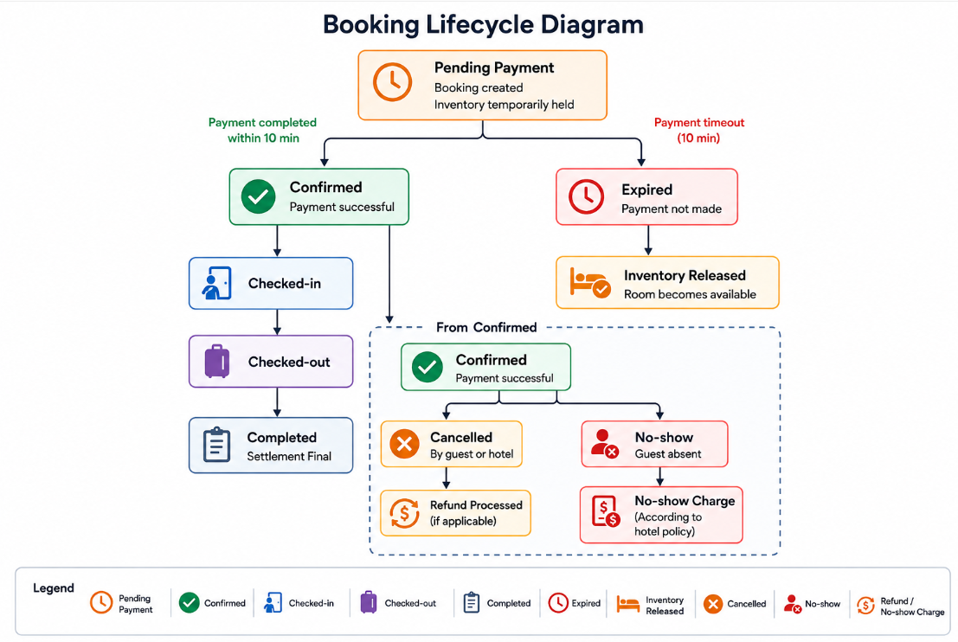
Business Rule

No-show: If a guest fails to arrive before the hotel's check-in cut-off time without cancelling the reservation, the booking shall be marked as No-show. The system shall process inventory, settlement, and applicable charges according to the merchant's configured no-show policy.

Merchant Actions for No-show
When a booking reaches the check-in cut-off time, the merchant can:
- Mark the booking as No-show.
- View the guest's booking details before confirming the no-show.
- Add internal notes (optional), such as "Guest could not be contacted."
- If the guest arrives late and the room is still available, change the booking to Checked-in instead of No-show (subject to hotel policy).

System Actions After No-show
- Release room inventory according to the hotel's configured no-show policy.
- Update room availability.
- Synchronize the booking status with the PMS or Channel Manager (if integrated).
- Apply settlement and commission calculations according to the merchant's no-show policy.
Pending Payment
If a customer initiates a booking but does not complete payment immediately, the booking shall remain in Pending Payment status for up to 10 minutes while the selected room inventory is temporarily reserved.
Merchant View
- Merchants can view Pending Payment bookings in the Booking Management module.
- Pending Payment bookings are clearly distinguished from Confirmed bookings.
- Pending Payment bookings cannot be checked in, checked out, modified, or settled.
System Actions
If payment is completed within the reservation period:
- Booking status changes to Confirmed.
- Payment status changes to Paid.
If payment is not completed within 10 minutes:
- The booking automatically expires.
- Reserved room inventory is released.
- Room availability is updated.
- The booking is excluded from settlement and revenue calculations.
- The customer must create a new booking to reserve the room again.

Module 5 – Business Dashboard, Earnings & Settlement

Goal: Provide merchants with a centralized operational dashboard and transparent visibility into hotel performance, earnings, commissions, settlements, and payout status.

Functional Requirements
- Dashboard summary with action cards for new bookings, pending confirmations, today's arrivals and departures, unread messages, system notifications, and operational alerts.
- Business performance metrics, including booking volume, room nights, occupancy rate, revenue, Average Daily Rate (ADR), commission, and payout indicators.
- Financial breakdown at the booking level, including booking amount, discounts, platform-sponsored promotions (if applicable), commission, deductions, taxes (if applicable), and net settlement amount.
- Settlement shall be processed per Booking ID, with each booking maintaining its own settlement status.
- Settlement statements with daily, weekly, or monthly views, subject to the configured settlement schedule.
- Settlement history, including Booking ID, payment reference, payout date, settlement status, and downloadable settlement reports.
- Payout status tracking (e.g., Pending, Processing, Paid, Failed).
- Reconciliation discrepancy reporting and settlement appeal workflow.
- Exportable financial reports and invoice support, where applicable.

5.1 Settlement Flow Overview
- Settlement is calculated per completed booking.
- Settlement Amount = Booking Amount − Commission − Merchant-funded Promotion (if applicable).
- Settlement status: Pending → Processing → Completed.
- Merchants can view settlement history and payout details and settlement status for each booking.
- Settlement reports can be exported.

5.2 Commission
- Commission is deducted according to the merchant agreement.
- Only merchant-funded promotions reduce the merchant's settlement amount.
- Promotions funded by mTrip, banks, or other partners do not reduce the merchant's settlement unless otherwise agreed.
- Detailed settlement rules may be refined during the payment and finance implementation phase.

5.3 Refund Rules
- Refund amount is determined according to the configured cancellation policy.
- Merchants can view refund status but cannot directly initiate wallet refunds.
- Refund processing is handled by the platform.

Module 6 – Notifications & Settings
Goal: Centralize merchant notifications, account settings, security preferences, and platform announcements to help merchants stay informed, manage their accounts securely, and respond to operational events efficiently.

Functional Requirements

6.1 Notification Management
- Receive in-app notifications for operational events and system activities.
- View notification history.
- Search and filter notifications.
- Filter notifications by category and read status.
- Mark individual notifications or all notifications as read.
- Open related modules or records directly from notifications.

6.2 Notification Categories
Support notifications for:
- Booking Notifications
- Inventory & Availability Alerts
- Synchronization Alerts
- Settlement & Payout Updates
- Customer Reviews
- Platform Announcements
- System Logs

6.3 Notification Content
- Display notification details including:
- Notification title
- Description
- Related property
- Date and time
- Read or unread status
- Notification category
- Quick action to view related details

6.4 Synchronization Alerts
- Notify merchants when PMS synchronization fails.
- Notify merchants when Channel Manager synchronization fails.
- Display synchronization error logs.
- Allow merchants to retry failed synchronization.

6.5 Merchant Profile & Preferences
- Manage merchant profile information.
- Update contact information.
- Configure notification preferences.

6.6 Security Settings
- Configure two-factor authentication (2FA).
- Manage trusted devices.
- View active sessions.
- Securely log out of the platform.
- Allow merchants to enable or disable biometric login from Settings > Security in the Merchant Mobile App only.
- Display the biometric label supported by the device, such as Face Scan, Fingerprint, or Biometrics, without creating separate flows based on fingerprint-sensor location.
- Bind biometric login to the same trusted mobile device and require full Merchant Access Code + 2FA authentication after a new device, app reinstallation, biometric enrollment change, or relevant security change.
- Do not display a biometric-login setting in the Merchant Web Portal/Dashboard.

6.7 Localization
- Configure language preferences.
- Configure timezone settings.
- Configure regional preferences where supported.

Module 7 – Role-Based Access Control (RBAC) & Staff Management
Goal: Enable the primary merchant account to manage staff members, assign role-based permissions, and control access to hotel resources while protecting sensitive business and financial information.

Functional Requirements

7.1 Staff Management
- Invite staff members via email.
- Manage staff accounts, including activation, deactivation, and account status.
- View staff information, assigned hotel, role, last login, and invitation status.
- Search and filter staff by name, role, assigned hotel, and account status.
- Resend pending staff invitations.

7.2 Role Management
- Assign predefined staff roles, including:
- Hotel Owner
- Hotel Manager
- Reservation Officer
- Update staff roles based on operational requirements.

7.3 Permission Management
- Configure module-level access through predefined role permission templates.
- Support permission levels including:
- Full Access
- Limited Edit
- View Only
- No Access
- Manage permissions for system modules, including:
- Hotel Properties
- Room Types
- Availability & Pricing
- Booking Management
- Business Dashboard
- Promotions
- Reviews
- Staff Management
- Settings
- Restrict access to sensitive business information, including revenue, commissions, settlements, payouts, merchant profile, and security settings.
- This now matches your Permission Matrix perfectly.

7.4 Hotel Assignment
- Assign staff members to one or more hotel properties according to their assigned roles.
- Restrict staff access to assigned hotel properties only.

7.5 Invitation Management
- Send invitation emails to new staff members.
- Track invitation status.
- Resend pending invitations.
- Configure invitation expiration periods.
- Exactly matches your Invite Staff modal.

7.6 Audit History
- Record staff-related activities and permission changes.
- Display audit logs including:
- Action performed
- Affected account
- Activity details
- Performed by
- Date and time
- Export audit history for administrative review.

7.7 Staff Dashboard
- Display staff management summary, including:
- Total Staff
- Active Staff
- Pending Invitations
- Disabled Accounts

Module 8 – Promotion & Campaign Management
Goal: Enable merchants to create hotel promotions, participate in platform campaigns, and monitor campaign performance to increase bookings and revenue.

Functional Requirements
- Create and manage promotional offers, including percentage discounts, fixed-amount discounts, promo codes, seasonal promotions, early booking offers, and long-stay promotions.
- Configure promotion rules, including eligible properties, room types, discount values, redemption limits, funding model, promotion validity periods, and optional terms and notes.
- Configure long-stay promotions with minimum stay requirements, eligible stay durations, discount values, and applicable room types.
- View, edit, duplicate, activate, pause, expire, and delete merchant-created promotions.
- Participate in platform campaigns by reviewing campaign details, eligibility requirements, funding model, campaign terms, and accepting or declining campaign invitations.
- Support merchant-funded, platform-funded, and co-funded promotional campaigns based on approved business rules.
- Monitor promotion and campaign performance through dashboards and analytics, including impressions, bookings, conversion rate, promotion revenue, and return on investment (ROI).

Module 9 – Reviews & Ratings Management
Goal: Enable merchants to monitor customer reviews, respond professionally, manage hotel reputation, and identify opportunities to improve service quality.

Functional Requirements
- View customer reviews, overall ratings, and review summaries across supported booking channels.
- Search and filter reviews by property, review status, rating, booking channel, and other available criteria.
- View review details, including reviewer information, booking channel, rating, review content, and review date.
- Submit and manage official merchant replies to customer reviews.
- View review status, including Published, Pending Review, and Flagged.
- Flag reviews for platform moderation in accordance with platform policies.
- Monitor review performance through average rating, published reviews, pending reviews, and flagged reviews.

Module 10 – Merchant Support & Help Center
Goal: Provide merchants with self-service resources and a structured support channel to efficiently resolve operational issues and improve platform adoption.

Functional Requirements
- Submit and manage support tickets for bookings, availability and pricing, settlements, reviews, room management, technical issues, and other operational inquiries.
- Track support ticket status, priority, assigned support agent, response history, and resolution progress.
- Access searchable FAQs organized by business categories to quickly resolve common questions.
- Download user guides, onboarding documentation, operational manuals, and technical integration guides.
- View platform policies, compliance rules, violations, penalty points, warnings, and appeal status.
- Search and filter support tickets, FAQs, user guides, and compliance information using available search and filter options.
- Receive notifications and status updates for support ticket progress, responses, and resolution.

10.1 Guest Messaging
Goal: Enable merchants to communicate with guests through real-time messaging to improve
customer service before, during, and after their stay.

10.2 Guest Conversations
- View conversations with guests across all hotel properties.
- Search conversations by guest name, booking ID, or hotel.
- Filter conversations by status (Open, Unread, Resolved).

10.3 Messaging
- Send and receive real-time text messages.
- Support image and document attachments.
- Display message delivery and read status.
- Maintain complete conversation history.

10.4 Booking Context
- Display guest booking information alongside the conversation.
- Allow quick navigation to the related booking.
- Show guest check-in and check-out dates.

10.5 Notifications
- Receive notifications for new guest messages.
- Show unread message count.
- Notify staff when guests reply.

10.6 Staff Assignment
- Assign conversations to hotel staff.
- Transfer conversations between staff members.
- Mark conversations as resolved.

Acceptance Criteria

These acceptance criteria define the minimum business outcomes for the aligned Merchant App

modules. Detailed field-level and exception criteria will be maintained during refinement.

Merchant Dashboard
- Merchants can view dashboard KPIs based on the selected property or all properties.
- Dashboard metrics display current booking, occupancy, revenue, and operational summary information.
- Operational alerts display synchronization failures, pending actions, and system notifications when applicable.
- Merchants can navigate directly from dashboard widgets to the corresponding management modules.

1. Registration, Verification & Admin Approval
- A merchant can register using a valid mobile number and complete OTP verification.
- A merchant can complete the merchant profile and upload all required verification documents.
- The system displays the current verification status throughout the approval process.
- Rejected applications display rejection reasons and allow resubmission after corrections.
- Only approved merchants who successfully complete authentication can access the Merchant Dashboard and operational modules.
- Merchant Access Code is generated after successful approval.
- A returning merchant who enabled biometric login can access the Merchant Mobile App using a supported biometric method on the same trusted mobile device.
- Three total failed biometric matches across all available biometric methods in one login session require fallback to Merchant Access Code + the current Google Authenticator 2FA code.
- Biometric login is not displayed on the Merchant Web Portal/Dashboard.

2. Hotel & Room Management
- Merchants can create and manage multiple hotel properties.
- Merchants can create and manage room types with complete room information, media, policies, and amenities.
- Hotel and room information can be saved as drafts before submission.
- Submitted hotel or room updates display review status, approval history, and rejection reasons.
- Previously approved hotel and room information remains visible until updated information is approved.
- Approved hotel information becomes available for customer booking after publication.
- Hotels with supported PMS integrations synchronize hotel information successfully.
- Hotels without PMS can manage hotel operations directly within the Merchant Portal.

3. Availability, Inventory & Pricing
- Merchants can update room availability, inventory, pricing, and booking restrictions through the calendar.
- Inventory is automatically deducted after confirmed bookings.
- Rooms cannot be sold when inventory reaches zero.
- The system generates alerts for low inventory, synchronization failures, and overbooking risks.
- Inventory and pricing remain synchronized with connected PMS or Channel Manager when integration is available.
- All availability, pricing, inventory, and synchronization changes are recorded in the change history.

4. Booking Management
- Merchants can search, filter, and manage bookings throughout the booking lifecycle.
- Authorized staff can confirm, cancel, check in, check out, refund, and mark eligible bookings as No-show.
- Booking status updates follow defined business rules.
- Booking information remains synchronized with connected PMS, Channel Manager, Customer App, and Admin Portal where applicable.
- Booking history records user actions, timestamps, synchronization events, and status changes.
- Merchants receive real-time notifications when new bookings are created or updated.

5. Business Dashboard, Earnings & Settlement
- Merchants can view operational KPIs, revenue, occupancy, booking performance, and settlement summaries.
- Financial information displays booking amount, discounts, commission, deductions, taxes (if applicable), and net settlement.
- Merchants can track settlement history and payout status.
- Merchants can export settlement reports and submit reconciliation discrepancies for review.

6. Notifications & Settings
- Merchants receive notifications for supported operational events.
- Notification history can be searched, filtered, and marked as read.
- Merchants can open related records directly from notifications.
- Merchants can update profile information, notification preferences, language, timezone, and security settings.
- Merchants can configure two-factor authentication, manage trusted devices, and securely log out.
- Synchronization failures generate notification alerts with related error details.
- Merchants can enable or disable biometric login from Merchant Mobile App Settings > Security when the device supports an enrolled biometric method.
- The mobile app provides an immediate Use Merchant Access Code fallback and requires Merchant Access Code + Google Authenticator 2FA after three total failed biometric matches, device lockout, or biometric unavailability.

7. RBAC & Staff Management
- The primary merchant account can invite, activate, deactivate, and manage staff accounts.
- Staff members are assigned predefined roles with the appropriate permission level.
- Staff access is restricted according to assigned hotels and permission settings.
- Invitation status and pending invitations can be monitored and resent.
- Permission changes and staff activities are recorded in the audit history.
- Staff dashboard displays current staff statistics, including total staff, active staff, pending invitations, and disabled accounts.

8. Promotion & Campaign Management
- Merchants can create, edit, duplicate, activate, pause, expire, and delete eligible promotions.
- Promotion rules validate eligible properties, room types, validity periods, discount values, and redemption conditions.
- Merchants can review and participate in platform campaigns when eligible.
- Campaign performance displays bookings, conversion, revenue, and ROI metrics.
- Promotion funding models are correctly reflected in booking and settlement information.

9. Reviews & Ratings Management
- Merchants can view customer reviews from supported booking channels.
- Reviews can be searched and filtered by property, status, rating, and booking channel.
- Merchants can submit and manage official responses to eligible reviews.
- Merchants can flag reviews for moderation according to platform policies.
- Review dashboard displays average rating, published reviews, pending reviews, and flagged reviews.

10. Merchant Support & Help Center
- Merchants can create and manage categorized support tickets.
- Merchants can monitor ticket status, assigned support agent, and response history.
- Merchants can access searchable FAQs, user guides, and technical documentation.
- Merchants can review platform compliance rules, warnings, violations, penalty points, and appeal status.
- Merchants receive notifications when support tickets are updated or resolved.
- Merchants can exchange real-time messages with guests.
- Conversations display related booking information and guest stay details.
- Merchants can send text messages and attachments.
- Staff receive notifications for new guest messages.
- Conversations can be assigned, transferred, and marked as resolved.

Design
The design artifacts for the Hotel Merchant App include workflow diagrams, information architecture, and UI concepts that support product discussions and development planning.

Hotel Merchant App Information Architecture
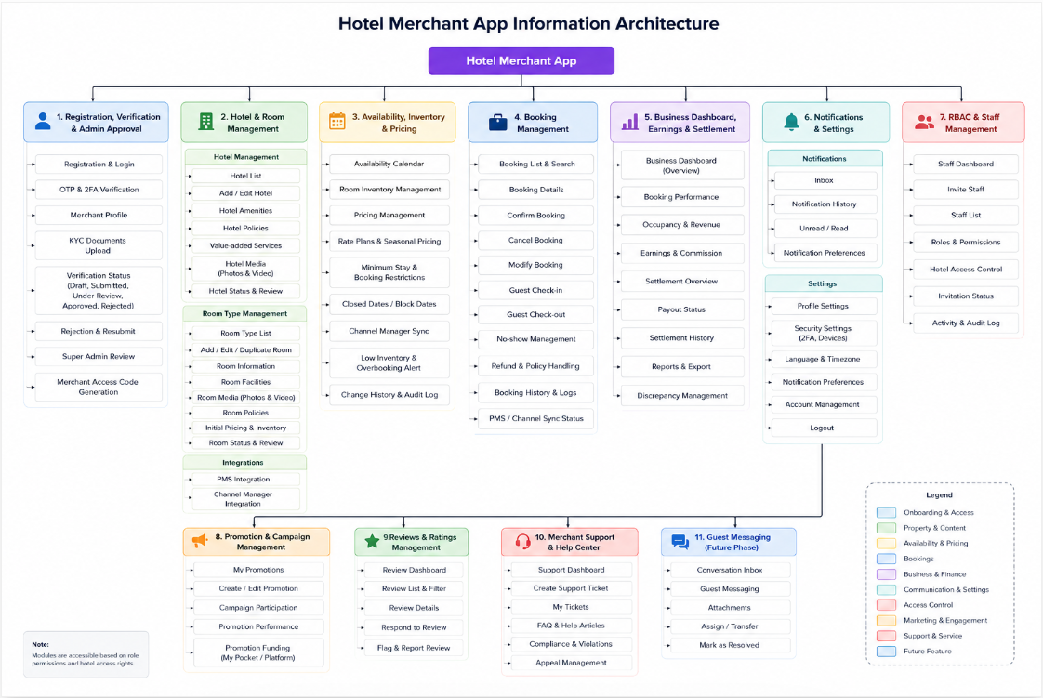

Hotel Merchant App Role-Based Access Control (RBAC)

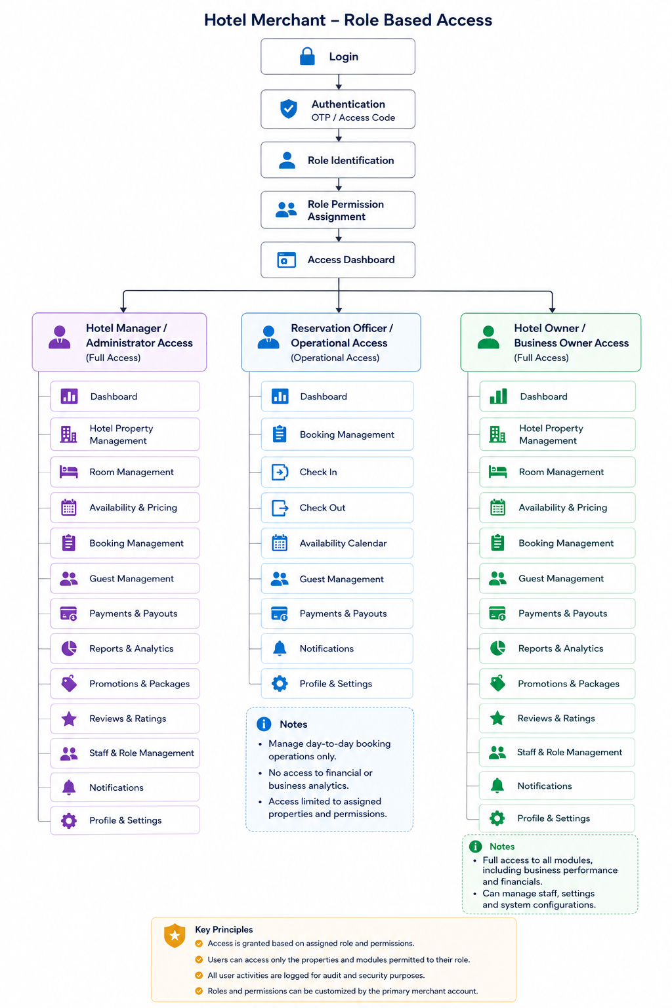

Design Link

Design Prototype Link of PO | https://big-plank-58319748.figma.site
UX/UI Figma Link from Design Team | Figma

Technical Considerations
The Hotel Merchant App will integrate with multiple core services within the mTrip ecosystem, including the Super Admin Portal for merchant verification and approval, the Customer App for hotel content and booking synchronization, notification services, and future payment and settlement services.
The solution architecture shall support reliable synchronization of hotel information, room inventory, pricing, bookings, promotions, reviews, settlements, and role-based access permissions across the Merchant Portal, Customer App, Super Admin Portal, and connected external systems.
Technical implementation details, API specifications, integration methods, data models, and infrastructure decisions will be finalized collaboratively with the Engineering team during the implementation phase.
Security-sensitive operations and financial transactions shall support:
- Secure authentication and mandatory authorization checks
- Role-based access control
- Audit logging
- Data encryption in transit and at rest
- Idempotent processing where required
- Error handling and retry mechanisms
- Integration monitoring and synchronization logs
The architecture should also support scalability and future integration with additional PMS providers, Channel Managers, payment gateways, settlement services, and other merchant categories.

PMS & Channel Manager Integration

Scenario 1 – Direct PMS Integration
Hotels with existing Property Management Systems (PMS) and Channel Managers shall be able to integrate with the mTrip Merchant Platform through supported APIs.
The integrations shall synchronize:

PMS Integration
- Hotel information
- Room types
- Room inventory
- Booking status
- Guest check-in / check-out status (where supported)

Channel Manager Integration
- Room availability
- Pricing and rate plans
- Room quota allocation
- OTA inventory synchronization
- Booking synchronization across connected Online Travel Agencies (OTAs)
Synchronization shall occur automatically according to the supported integration capabilities, ensuring consistent hotel data across the Merchant Portal, PMS, Channel Manager, and connected OTA platforms.
Scenario 2 – mTrip Merchant Platform as PMS
Hotels without an existing Property Management System (PMS) may use the mTrip Merchant Platform as their primary hotel management system.
Merchants shall be able to manage:
- Hotel information
- Room types
- Room inventory
- Availability
- Pricing
- Bookings
When Channel Manager integration is available, the mTrip Merchant Platform may synchronize inventory, availability, pricing, and booking status with supported Online Travel Agencies (OTAs).
Scenario 3 – Manual Operation
Hotels that do not have a supported PMS integration or Channel Manager integration shall be able to manage hotel operations manually through the mTrip Merchant Platform.
Merchants shall be able to manually update:
- Hotel information
- Room inventory
- Availability
- Pricing
- Booking status
until a supported integration becomes available.

Business Rule
- A hotel shall use only one inventory source at a time to prevent inventory conflicts and overbooking.
- When PMS integration is enabled, the PMS shall be the primary source of truth for inventory and booking status.
- When PMS integration is unavailable, the mTrip Merchant Platform shall become the primary source of truth.
- Channel Manager synchronization shall only be available for supported providers and integration configurations.

Additional Technical Considerations

Real-time Booking Notifications
The platform shall deliver real-time notifications to merchants for new bookings, booking updates, cancellations, and other operational events. Merchants shall be able to navigate directly to the related booking details from the notification.

Room Quota Synchronization
The synchronization of room quota allocation between the Merchant Portal and supported PMS or Channel Manager integrations shall be validated with the Engineering team to determine the appropriate synchronization strategy and technical feasibility before implementation.

Scalability & Extensibility
The solution architecture shall support future expansion without requiring significant architectural changes, including support for:
- Additional PMS providers
- Additional Channel Manager providers
- Payment gateway integrations
- Settlement service integrations
- Additional merchant business categories
- Future third-party integrations

Success Metrics
The success of the Hotel Merchant App will be measured based on merchant adoption, operational efficiency, platform reliability, booking performance, and business growth.
- Increase the number of verified hotel merchants successfully onboarded to the platform.
- Improve the completeness and accuracy of hotel information published and synchronized with the Customer App.
- Reduce manual operational effort through streamlined management of inventory, pricing, bookings, and supported PMS and Channel Manager integrations.
- Increase merchant adoption and engagement through regular use of the Merchant Portal and its operational features.
- Improve booking management efficiency by reducing booking processing time and minimizing synchronization issues.
- Maintain reliable synchronization of hotel information, inventory, pricing, room availability, and booking status across the Merchant Portal, Customer App, Super Admin Portal, and supported external integrations.
- Deliver a secure, reliable, and scalable merchant platform that supports future business growth and additional merchant categories.

Open Issues
The following business decisions require further clarification before implementation.
- What are the business rules for merchant-initiated booking cancellations, refunds, compensation, and no-show handling?
- What is the payout schedule, settlement cycle, and commission calculation process for completed bookings?
- Which promotion and campaign features will be included in the Phase 1 MVP?
- Which Property Management System (PMS) providers and Channel Manager providers will be supported in Phase 1?
- Will settlement processing be managed internally by mTrip or through an external payment or financial service provider?

Q&A
What are common questions about the product along with the answers you’ve decided? This is a good place to note key decisions.

Asked by | Question | Answer
Product Team | Who can register as a hotel merchant? | Hotels with the required business information and verification documents can register through the Hotel Merchant App.
Product Team | Is merchant verification required before using the application? | Yes. Merchant verification and approval are required before accessing hotel management features.
Product Team | What documents are required for merchant verification? | Business Registration Certificate, Hotel License, and Owner/Representative ID or Passport, Bank Account Information, Bank Passbook / Bank Certificate, Tax Registration Certificate, Premises Ownership / Lease Agreement
Product Team | Can a rejected merchant apply again? | Yes. Merchants can update the required information and resubmit their application for review.
Product Team | When will a hotel be visible in the Customer App? | After merchant approval and completion of the required hotel information, room setup, availability, and pricing.
Product Team | Who can manage bookings? | Hotel staff with the appropriate role permissions can manage bookings based on the RBAC policy.
Product Team | How will hotel bookings be received? | Bookings made through the Customer App are synchronized to the Merchant App for management.

Feature Timeline and Phasing

Feature | Status | Dates
Registration, Verification & Admin Approval | In Review
Hotel & Room Management | In Review
Availability, Inventory & Pricing | In Review
Booking Management | In Review
Business Dashboard, Earnings & Settlement | In Review
Notifications & Settings | In Review
Role-Based Access Control (RBAC) & Staff Management | In Review
Promotion & Campaign Management | In Review
Reviews & Ratings Management | In Review
Merchant Support & Help Center | In Review
Guest Messaging | In Review

Reference and Scope Note
Ctrip EBK serves as a reference for established hotel merchant operations, including merchant workbench, property and room management, availability and rate management, booking lifecycle, settlement, reviews, staff management, and campaign management. The mTrip Merchant Platform is inspired by these proven workflows but is designed to address its own business requirements and market needs. Therefore, not all Ctrip EBK capabilities will be included in the Phase 1 MVP. Features such as merchant onboarding, mandatory two-factor authentication (2FA), affiliate and influencer management, and future multi-category merchant support are unique to the mTrip product roadmap.

PRD Checklist:
Here’s a list of topics you must include in your PRD:

PRD Checklist
Order | Topic | Done
1. | Title | Completed
2. | Author | Completed
3. | Decision Log | In Progress
4. | Change History | In Progress
5. | Overview | Completed
6. | Success Overview | In Progress
7. | Messaging | Backlog
8. | Timeline/Release Planning | In Progress
9. | Personas | Completed
10. | User Scenarios | Completed
11. | User Stories/Features/Requirements | In Review
12. | Features In | In Progress
13. | Features Out | In Progress
14. | Design | In Progress
15. | Open Issues | In Progress
16. | Q&A | Backlog
17. | Other Considerations | Backlog

Change History

Version | Date | Changes
1.0 | Aug 14, 2026 | Initial Merchant App PRD covering the defined modules, requirements, and workflows.
1.0.1 | Sep 2, 2026 | - Clarified that biometric login is available only on the Merchant Mobile App and is not available on the Merchant Web Portal.  - Added optional biometric enablement from Merchant Mobile App Settings > Security after the merchant completes the first login using Merchant Access Code + Google Authenticator 2FA.  - Added trusted-device requirements and clarified that biometric login does not require additional KYC, liveness detection, or facial verification.  - Added a maximum of three total failed biometric attempts across Face and Fingerprint within the same login session, subject to device or operating-system limits.  - Added fallback to Merchant Access Code + Google Authenticator 2FA after the third failed biometric attempt, OS lockout, biometric unavailability, or when the merchant selects Use Merchant Access Code.  - Added full-authentication requirements for a new device, app reinstallation, biometric enrollment changes, or relevant security changes.  - Clarified that the Merchant Web Portal supports either Merchant Access Code + Google Authenticator 2FA or QR Code Login through an already-authenticated Merchant Mobile App.  - Updated the end-to-end registration, approval, first-login, biometric setup, future mobile login, and Web Portal login flow diagram.

